As Henry find this SO:4028528 Lines 59 and 63

Delivery Number 800298853  not close drop-off , has problem to send EDI to SAP

(Shipping line is interfaced, but delivery status is not closed ,waiting drop-off)

(User get some problem on shipping this SO; This also may due to LPN netterm data crap …)

And advice to use below action to close the delivery ,please find a shipping user to do this:

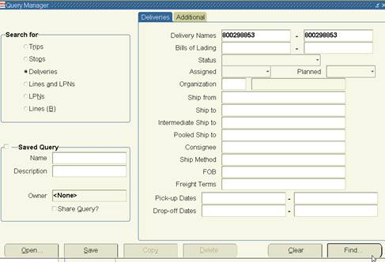

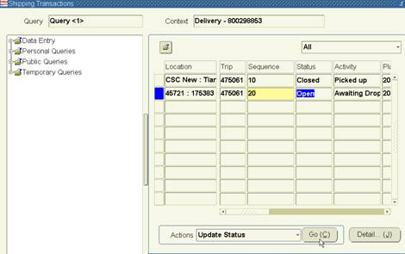

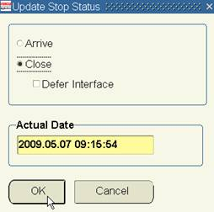

This can Solved